Woodworth’s Interaural Time Difference

1: ITD formula

ITD = r (θ + sin θ)/C

r = 0.57 m, the average radius of the human head in m

c = 343 m /s, the speed of sound in M

θ = bearing of a far field source or also known as azimuth

ITD = Interaural Time Difference also described as the time difference of when the sound was received by human ears

2: Finding the θ

r (θ + sin θ) = itd \* C

(θ + sin θ) = itd \* C / r

IF θ = 90

3: trial and error and explanation

ITD = 57 (90 + SIN 90) / 34300

57 \* 91 /34300 = 5096 / 34300 = 0.14857142857142857142857142857143 s

if itd = 14.8571429

(θ + sin θ) = 0.14857142857142857142857142857143 \* 34300 / 57

(θ + sin θ) = 89 about 2 degrees off but almost accurate

we can estimate (θ + sin θ) as our azimuth even since finding ITD here will be easier than finding the θ which is described as a bearing of a far field source, what does that mean? "In mathematics, a bearing is the angle in degrees measured clockwise from north. Bearings are usually given as a three-figure bearing. For example, 30° clockwise from north is usually written as 030°" (Bearings - Using bearings in trigonometry - National 5 Maths Revision - BBC Bitesize, 2021) this means the bearing of a far field source here is our angle for the source of the sound which is what we need to turn the robot .

using this formula we can calculate azimuth by finding the time difference in which the time difference between when the first microphone received a sound wave and when the second one received the time wave in which itd is to T2 - T1 to where T2 is the time it took for the sound to reach that microphone since the program has been run and where T1 is the same but for the microphone that received the sound first so will say T2 = 5.6 and T1 is = 5.8 so itd here will be = to 0.2 in this case we will use it to where 0 + sin 0 = 0.2 \* 343 / half the distance between the 2 microphones assuming the distance between the microphones is the premier and half of that would be the radius of the robot's head , using this function it will be possible to use any robot with 2 microphones and apply this for sound loc.

although I will need more trial an error testing to prove that this formula work before using it to make sure it works and makes sense, this formula is called wood worth’s interaural time difference formula, there are many other formulas for ITD till now this is the most famous one

4: code explanation

DISCLAIMER: this is section WILL NOT have any code it is more of an explanation on how I Plan to code my robot and what will the code do, this might change in the future or to be improved on it is just meant to give an idea on how the program could function.

The program will set the robot into 3 different modes listening, locating, and moving.

when the program starts it will listen for which microphone received the signal first left or right, then it will move 90 degrees to the left or 90 degrees to the right depending on which when received the signal first , using the ITD where a timer starts when the program runs and when a microphone receives the signal will be added to a value , lets says first microphones value Is called T1 and second is T2 , T1 is for the right and T2 is for the left if T1-T2 = negative that means the target is on the right if it was positive then the target is on the left so if T1 > T2 then robot turns left else if T1 < T2 ten robot turns to the right , else if T1 = T2 then target is either on the back or the front , is this situation we need to let the target go exactly 90 degrees in any direction why ? since it will have to go to the next mode which is locating , locating when the first ITD is = 0 is easier because then we can use the ITD again to find if the target was to front or to the back , look at figure 1 for visual explanation.

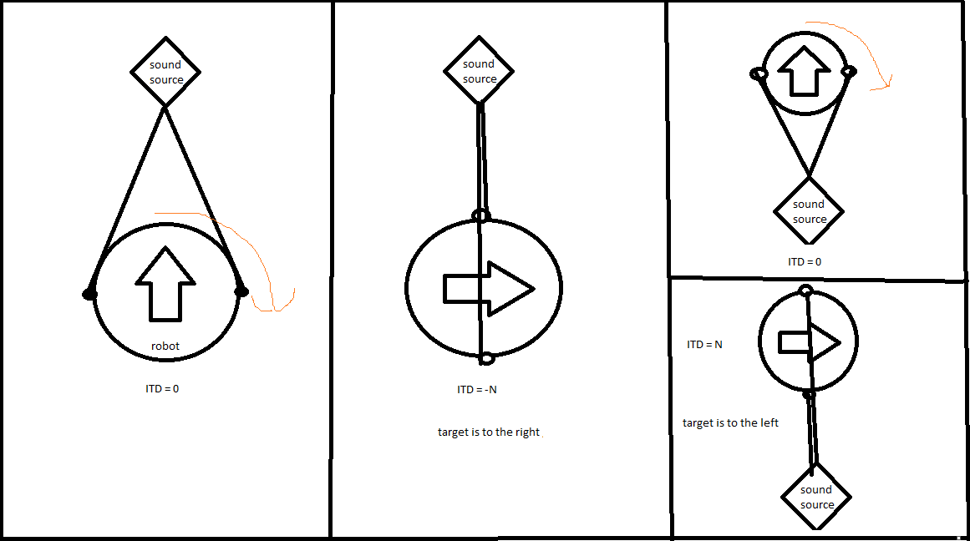

Figure 1

If ITD is not at zero time difference still wont get us the exact angel , but will get us the exact angle from in a 180 degrees where it will locate from 270- 90 degrees , an example below is shown in figure 2 where 45, 135 , 225 and 315 all have the same ITD therefore it is not possible to locate exact location with just one ITD , depending on which microphone receives the signal first it will move 90 degrees in that direction , all of that will be during the listening mode.

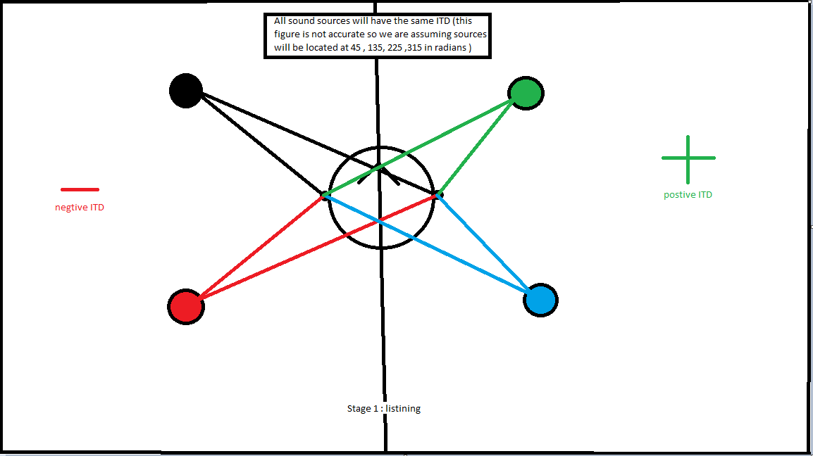

Figure 2

When the robot is done with listening and goes to the location it then has to use ITD again to find if it is to the respective direction upwards or downwards (shown in figure 3 ) and will the have to use the ITD formula which as of writing this section of the presentation I am still using Woodworth’s formula in order to find the azimuth , more on that in figure 4

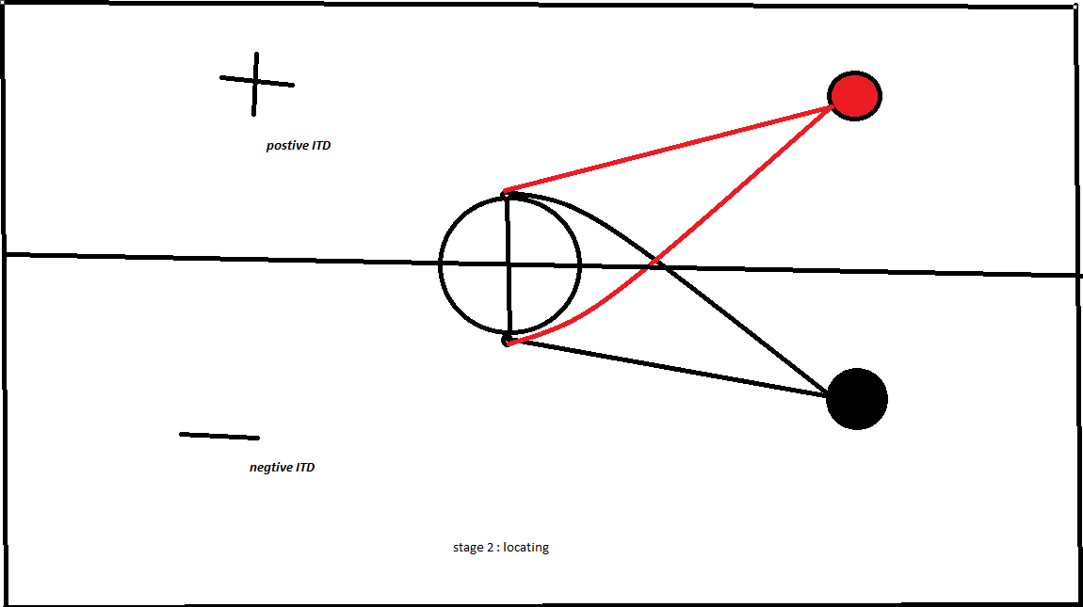

Figure 3

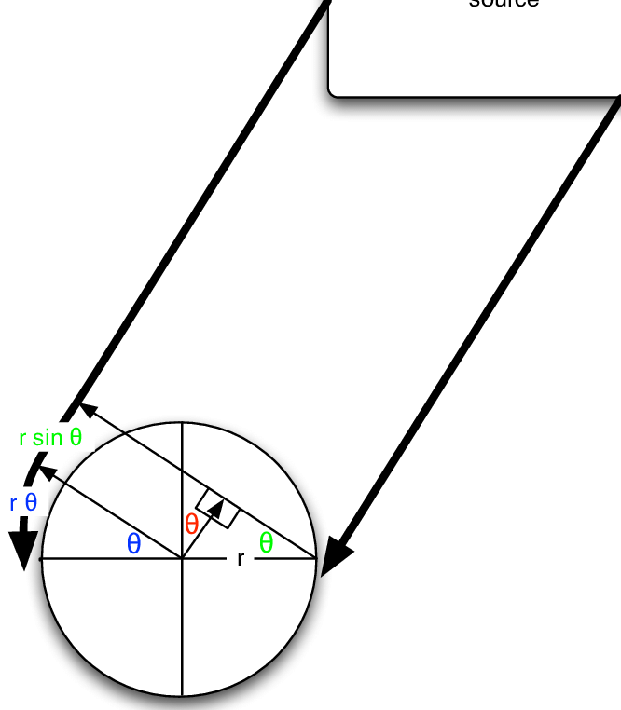

Figure 4

Cohen, Michael. (2010). Under-explored dimensions in spatial sound. 10.1145/1900179.1900199.

Once the target has Benn found it will move then the microphones will detect the intensity of the sound since we are going to use a buzzer which means Constant will be playing the more the intensity of the sound increases the closer we get to the source of the sound , depending on how loud the buzzer we will use is , the intensity of that buzzer will be measured in order to figure out the amount of decibels (DB) measured for the robot to estimate that it has reached the source of the sound DB is the how we measure the sound intensity / sound presser .

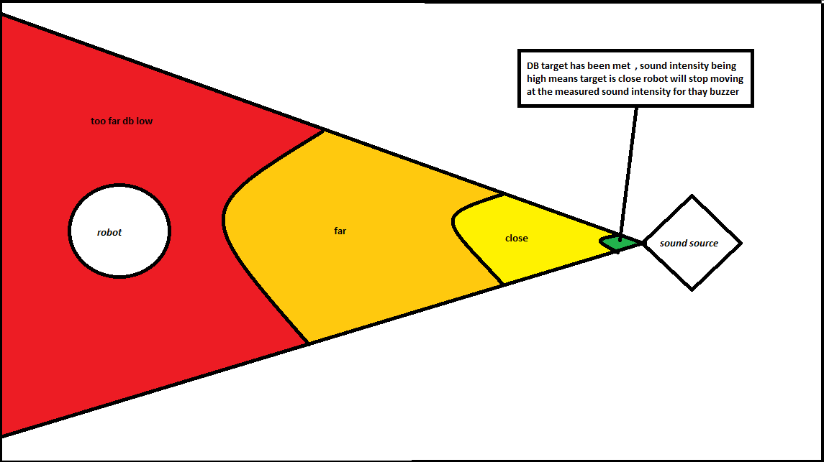

5: citation

1 Cohen, Michael. (2010). Under-explored dimensions in spatial sound. 10.1145/1900179.1900199.

2 BBC Bitesize. 2021. Bearings - Using bearings in trigonometry - National 5 Maths Revision - BBC Bitesize. [online]